For anyone (like me) with a perfectly serviceable Spektrum DX7 8 cell transmitter, using a plane with SAFE functionality can be problematic. SAFE is set to operate on CH5, which on the DX7 is a two position switch. This usually results with only having intermediate and expert settings. A little Google searching led me to the following post in RCgroups where a brilliant fellow named Ivan was able to sort the problem out for someone in the same boat as I. Below is a the step by step Ivan created to reassign CH5 to the 3 position flap switch allowing full SAFE functionality. Note that none of this is in the factory manual for the older version of the DX7.
The link to the entire post is here: https://www.rcgroups.com/forums/showthread.php?2530382-DX7-how-to-program-the-switches-freely
I followed these steps on my own DX7 for a recently acquired Apprentice and can confirm that it works as advertised. I hope someone else will find this useful!
-----------------------------------------------------------------------------------------------------------------------------
Uwe,
Took me a while to dig out my DX7, find a battery for it and refresh my memory on how it was programmed but at the end managed to get it to work with the 3-position switch controlling channel 5 and the 2-position GEAR switch controlling channel 6. You have to follow this:
1. First you need to go to the SYSTEM MENU - with the transmitter turned off press down and hold the DOWN and SELECT buttons while turning on the power.
2. Go to [INPUT SELECT] :
2.1. Change AUX2: to 3P SW and AUX2 TRIM: to INH. This will be used to mix the AUX2 channel (ch. 7) to channel 5 (GEAR) so you can use the 3-position switch to control it.
2.2. Change FLAP: to INH and FLAP TRIM: to INH - this is needed to disable any controls on channel 6 (FLAP) as you can not select directly a 2-position switch to control it. We'll do that with a mix from the GEAR switch further down in step 5.
3. Press DOWN and SELECT at the same time to get to the main transmitter screen.
4. Press DOWN and SELECT again to get into the main adjustment menu.
5. Go to [PROG.MIX1] and enable it by pressing either the INCREASEor DECREASE button.
5.1. On the second line change the master control (to the left of the arrow) to GEAR.
5.2. Also on the second line of the menu change the slave channel (to the right of the arrow) to FLAP. Use the SELECT button to scroll through the fields inside the mix menu.
5.3. Scroll to RATE: and flip the GEAR switch in one position, then change the active rate value to +100%; flip the GEAR switch in the other direction - the arrow in rate will move to the other value - change that one also to +100%.
5.4. Make sure that SW: is set to ON and OFFSET: is at 0. If they are not change them to those values.
What we achieved in step 5 is to make the GEAR switch (2-position) control the FLAP channel 6.
6. Go to [PROG.MIX2] and enable it - navigating through all PROG.MIXes is identical so I will skip describing which buttons to use - check that in step 5.
6.1. Change the master control on line 2 to the left of the arrow to GEAR.
6.2. Change the slave channel on line 2 to the right of the arrow to GEAR which is channel 5.
6.3. Enter -100% for BOTH values of RATE: - remember you will need to flip the GEAR switch to select one of the values then the other one in the same manner as in step 5.2.
6.4. Make sure SW: is set to ON and OFFSET: to 0 and if not change them accordingly.
The mix in step 6 disables the 2-position GEAR switch from controlling the GEAR channel 5 because we want channel 5 (GEAR) to be controlled by the 3-position switch instead.
7. Go to [PROG.MIX3] and enable it.
7.1. Change the master control to the left of the arrow on line 2 to AUX2.
7.2. Change the slave channel to the right of the arrow on line 2 to GEAR.
7.3. Change both RATE: values to +100% - this time you will have to flip the 3-position switch to select each rate value so you can change it.
7.4. Make sure SW: is set to ON and OFFSET: to 0 and if not change them to those values.
What we achieved in step 7 is to use the 3-position switch to control the GEAR channel 5.
8. Go to the servo monitor screen and confirm that the switches are operating channels 5 and 6 as desired. If necessary reverse channel 5 (GEAR) and/or channel 6 (FLAP).
That's it! Enjoy your DX7!
Ivan
This first screenshot is from the end result of step 2:
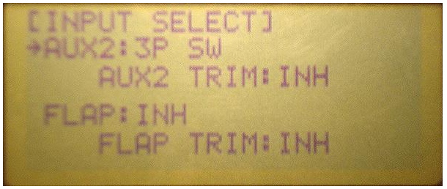
The 3-position switch is controlling the AUX2 channel 7 which later in step 7 will be mixed into the GEAR channel 5.
Next is the end result of step 5:
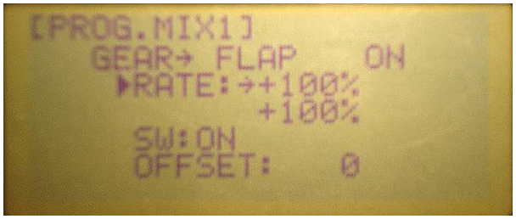
Here we set up the 2-position GEAR switch to control the FLAP channel 6.
Step 6 settings:
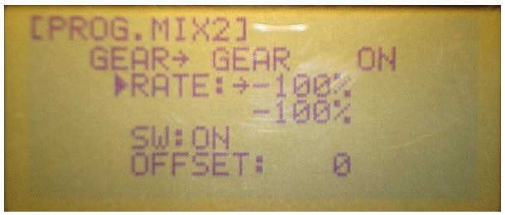
Here we disable the 2-position GEAR switch from controlling the GEAR channel 5 - note both negative 100% values for RATE!
Step 7 settings:
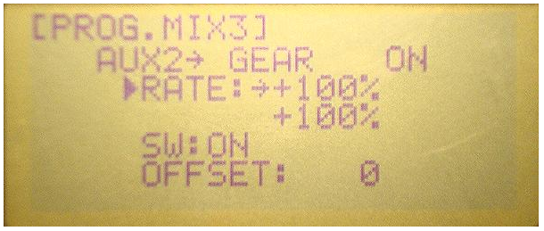
Mixing the AUX2 control (which we set up in step 2 to be the 3-position switch) into the GEAR channel 5.
The next 3 screen shots are of the servo monitor with the 3-position switch in each position - it is controlling the GEAR channel 5 as it is the AUX2 channel 7:
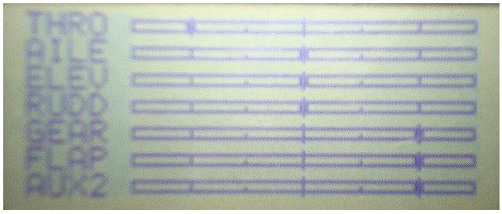
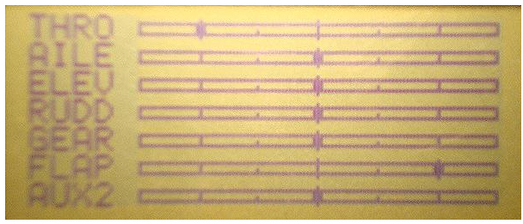
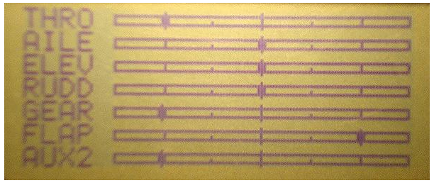
The last 2 screen shots are of the 2-position gear switch controlling the FLAP channel 6: